Contemporary Nepali On-line Dictionary User Manual
When you open the dictionary web page, the dictionary is already waiting for you to input a word with the cursor positioned in the search box. Figure 1 shows the word "सुरु" in the search box, assuming that you have typed or pasted the word there.

In order to provide input in search input box, there is no need to change the keyboard layout in your system to provide Nepali input as default input has already been set to Nepali. Even if you don't have Nepali input system in your computer, you can still provide Nepali input in the search input box. If you are familiar with input system of “Nepali Unicode Romanized” keyboard layout, you can provide input in the same manner. If you are not familiar with the default layout offered in search input box, you can change the keyboard layout by selecting the “Nepali Unicode Traditional” keyboard layout as shown in figure 2.

If you want to learn how to type in Nepali Unicode, please refer the following URL:
http://mpp.org.np/index.php?option=com_content&task=view&id=21&Itemid=42

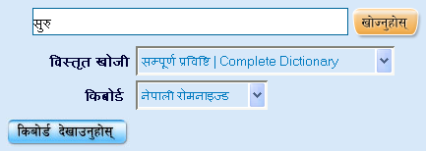

Fig. 1: Providing Nepali input

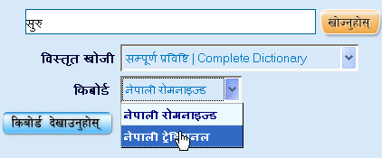

Fig. 2: Changing keyboard layout

Other option to provide input in the search input box is by using the “On-screen Virtual Keyboard”. To obtain the “On-screen Virtual Keyboard”, click the link as shown in figure 3.
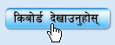
Fig 3: Obtaining “On-screen Virtual Keyboard”

When you carry out the operation as in figure 3, you can see the “On-screen Virtual Keyboard” as that of figure 4. When you click the link 'किबोर्ड लुकाउनुहोस्' again, the displayed keyboard hides from the screen.

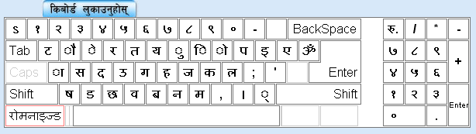
Fig. 4: On-screen virtual keyboard

Virtual Keyboard (VK) may be helpful to those users who don't have Nepali input system in their computer. You can provide input in the search input box by clicking on the desired characters on the “On-screen Virtual Keyboard”. By default virtual keyboard loads “Nepali Unicode Romanized” keyboard layout. If you prefer to switch keyboard layout into “Nepali Unicode Traditional” keyboard layout, you may click the bottom left button labeled “रोमनाइज्ड” as in figure 5. When you click that button, it shows you a menu from which you can click "ट्रेडिसनल" from the shown menu to obtain “Nepali Unicode Traditional” keyboard layout.

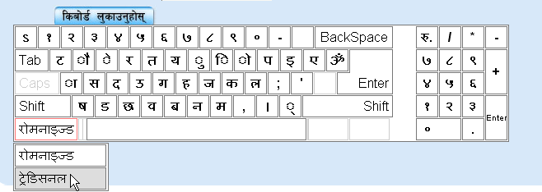
Fig. 5: Changing keyboard layout in “On-screen virtual keyboard”

In any of the available keyboard layouts, if you need characters which are in the shift state of the keyboard layout, you may click the button with label “Shift” which loads characters which are mapped to the shift state of respective keyboard layout. In both keyboard layouts, characters mapped to shift state differ from each other.
Figure 6 shows the keyboard layout of “Nepali Unicode Romanized” Keyboard Layout in shift state.
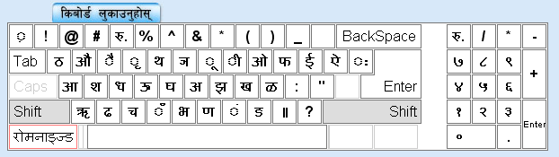
Fig. 6: “Nepali Unicode Romanized” keyboard layout in shift state

By default, when the search query is given, search operation is executed in the complete dictionary. This behavior can be altered by selecting the desired word type as in figure 7. If you prefer to get the results from complete dictionary, search operation can be performed in the complete dictionary. But if you are sure about the word and its type, you may select the desired word type as in the figure 7.

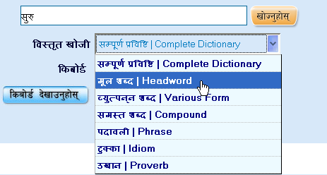

Fig. 7: Changing search criteria

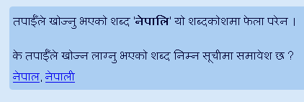
If you are not sure about the right spelling of the word, you may provide the spelling you know. Most of the time, “Spelling suggestions” might help you to find the right spelling. If there is small variation in the spelling you've provided, “Spelling suggestions” might find and list a set of words which have similar patterns. Figure 8 shows the feature of “Spelling suggestions”.

Fig 8: Demonstration of “Spelling suggestion”

“Auto-Suggestion” suggests nearest matching words in the real time while you're providing input. This will be helpful to find the desired word quickly without typing completely. From the given suggestions, you may select the suggested words either using mouse cursor or the up/down arrows from the keyboard. When the desired word is selected, you may click the button labeled 'खोज्नुहोस्' to execute the search operation.
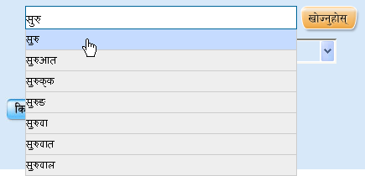

Fig. 9: Demonstration of “Auto-Suggestion”

When you click the button labeled 'खोज्नुहोस्' after providing a search query, search result is displayed just like it is shown in figure 10. When the search operation is performed in the complete dictionary, the result contains all the matching dictionary entries found in this dictionary. The result may contain entries with same spelling or similar spelling as provided in your search query. If you prefer to get entry details without getting the search result as shown in figure 10, you can select the specific word type as in figure 7 and perform the search operation again.
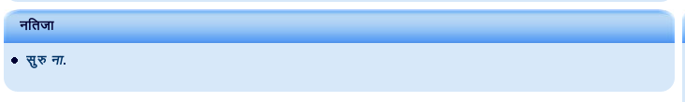
Fig. 10: Search result

When any of the links from a search result (figure 10) is clicked, you'll get the entry details as in figure 11.

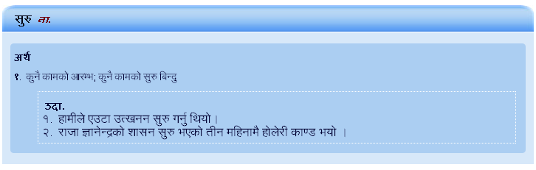
Fig. 11: Dictionary entry details

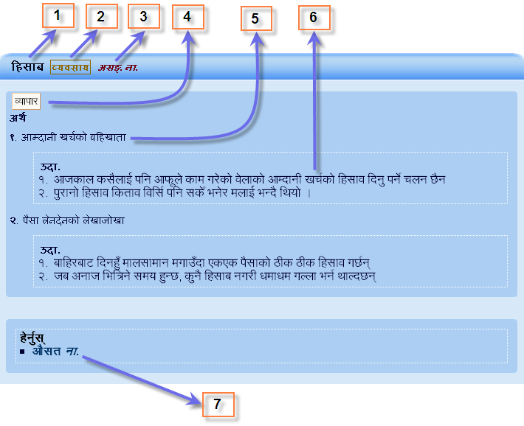
Fig. 12: Labeled dictionary entry details

In the figure 12, labels given to the different sections of dictionary entry are as follows :

- Headword
- Guide word
- Part-of-speech
- Pragmatic
- Definition
- Example
- Cross-reference (CR)
- You might find CR on definitions or usage notes of headword or various form entries.

When you search terms in this dictionary, those searched terms are displayed in the right pane of the window. You can get the result of any searched terms by clicking the link provided for that term. This will be speed-up the task as well as help you track the searched terms during that session. The top right pane with label 'खोजिएका शब्दहरू' of the figure 14 demonstrates this feature.

Sometimes, the word which you are currently viewing may occur in the definition of other dictionary entries. The bottom right pane with label 'यसमा समावेश छ' lists those words which contains the word 'सुरु' in their definition.
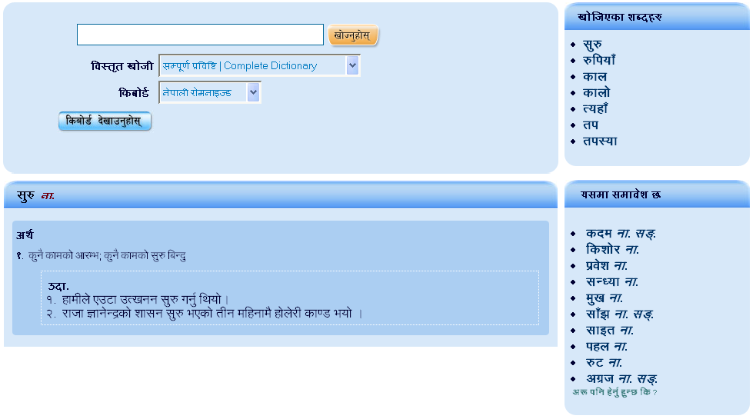
Fig. 13: Contemporary Nepali Online dictionary

